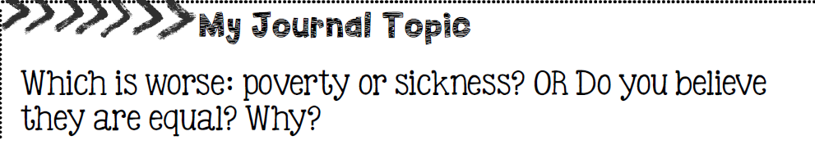
* The American Dream is the belief that anyone, regardless of where they were born or what social class they were born into, can achieve their own version of success in a society where people can move up in social hierarchy. (Remember how we looked at social hierarchy in ancient Egypt? In that society, people could rarely change the social class they were born into. In Canadian society today, people can change the social and economic class they were born into.)

